## **1.** **Introduction**

Our basic idea is to develop a data driven application to automate the numerous application submission process and its tracking.

**“Automation applied to an efficient operation will magnify efficiency.”**

## **1.1 Project Title**

**“Document Flow Application”**

## **1.2 Project Overview Statement**

**Project Overview Statement Template**

|  |
| --- |
| Project Title:  **Document Flow Application** |
| Group Leader:  **Asad Shabir** |
| Project Members:   |  |  |  |  | | --- | --- | --- | --- | | Name | Registration # | Email Address | Signature | | Asad Shabir | BSEF17M520 | bsef17m520@pucit.edu.pk | Asad | | Muhammad Hassan | BSEf17M541 | bsef17m541@pucit.edu.pk | hassan | | Minahil Mustafa | BSEF17M518 | bsef17m518@pucit.edu.pk | Minahil | | Zain Ul Abideen | BSEF17M517 | bsef17m517@pucit.edu.pk | Zain-ul-abideen | |  |  |  |  | |  |  |  |  | |
| **Project Goal:**  To develop an automated system that would track the document flow throughout the application process. |
| |  |  | | --- | --- | | Sr.# |  | | 1 | To automate most of the application process | | 2 | Instant acknowledgement of problem resolution. | | 3 | Better record keeping of applications. | | 4 | Allow students to submit applications from anywhere anytime. | | 5 | Ease of access for faculty to respond and handle applications efficiently. | | 6 | Reduce the amount of physical space used to store documents, such as file cabinets, boxes and shelving. | |
| **Project Success criteria:**   1. Motivation of Group members. 2. Proper coordination of Group Members. 3. Proper knowledge of frontend and backend libraries of MERN stack. 4. Proper knowledge of application domain. 5. Manage to meet all milestones in time. |
| **Assumptions, Risks and Obstacles:**  It is assumed that all the team members have the following skills:   * React js & React Native * Node js * Express js * MongoDB * Logical Reasoning * Software Project Management |
| **Organization Address (if any):**  **N/A** |
| **Type of project:**  **Development** |
| **Target End users:**  **All Stakeholders** |
| **Development Technology:**  **Structured** |
| **Platform**:  **Web based Mobile Application** |
| **Suggested Project Supervisor:**  **Sir Hassan Khan** |
| **Approved By:** |
| **Date:** |

## **1.3 Project Goals & Objectives**

**1.3.1 Goal:**

We will study the manual application submission process in the organization and automate it.

**1.3.2 Objectives:**

* It will be an online system so that clients can submit applications to admins digitally.
* Make the system to allow faculty to respond to our applications.
* Preserve records throughout their life cycle.
* Provide ease of access to students seeing the current status of application, fast searching & retrieval of applications anytime.
* Simplify the activities, systems, and processes of record maintenance.
* Allow instant access to documents.
* Automate the administer policies and procedures.
* Reduce the lost and misfiled documents.
* Streamline information and workflow.
* Entertain FAQ.

## **1.4 High-level system components**

* Clients can choose any form as per their requirements.
* Clients can create entirely new forms or customise older forms as per their requirements and send for approval to the admin.
* Clients will be able to get notifications regarding his/her Query Form e.g Submitted, In-Progress, Finished and Response etc.
* ChatBot for instant replies.
* Keep track of his forms progress.

## **1.5 List of optional functional units**

* IOS compatibility
* Response time should be reasonable.
* Responsive Frontend

## **1.6 Exclusions**

* Client and Admin chat system

## **1.7 Application Architecture**

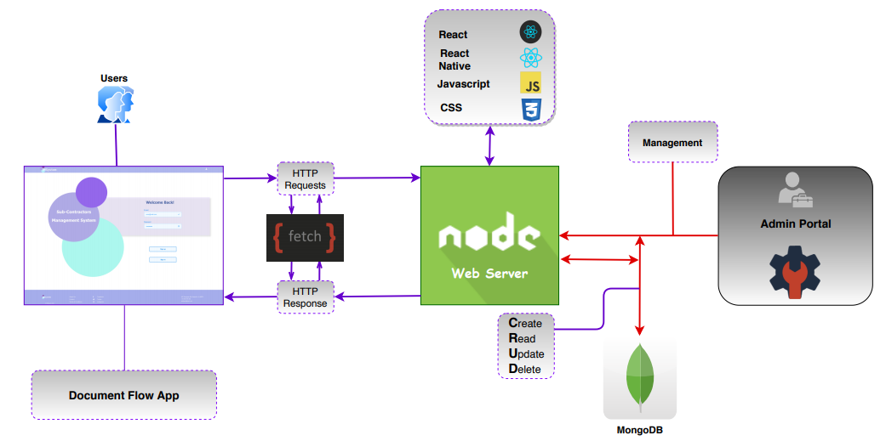

## 

## 

## 

## 

## 

## **1.8 Gantt chart**

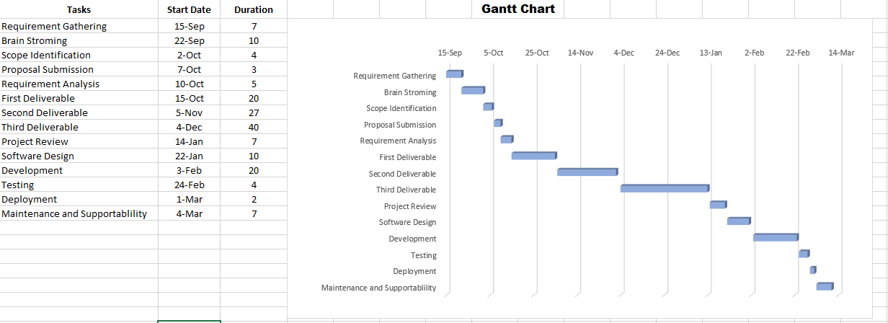

## **1.9 Hardware and Software Specification**

**1.9.1 Hardware Specs:**

* **Processor:** Pentium 4 or more for better performance.
* **RAM:** 2 GB (minimum) or more (recommended)
* **Hard Disk:** minimum 120 GB or more (recommended)
* **Empty Storage:** 200MB (For mobile app)

**1.9.2 Software Specs:**

* Android v4.0+ (Mobile App)
* Any modern Browser with Javascript Support

## **1.10 Tools and technologies used with reasoning**

* **Time constraint**: 10 months
* **Development lifecycle**: Agile Development
* **Host**: Netlify/Heroku
* **Target Platform** Web Browsers & Android Mobiles.
* **Technologies :** Javascript, React, React Native, Node js, Express js, MongoDB
* **Existing Tools:** GitHub, VSCode